Step 1 (1. Data Dive (10 pts)):

Dataset selected: Netflix Shows

Database name: Netflix

Table name: Shows

* Briefly explain any difficulties and 1 interesting thing you noticed about your chosen dataset.

1. No difficulties as followed by the video tutorial on the importing process.
2. Interesting observation:

Many Netflix shows are categorized under multiple genres, often leading to long, comma-separated lists in the listed_in column. This highlights the diverse content and broad categorization used by Netflix.

Step 2. Data Fun (20 pts):

* Use simple SQL queries to play with the data.
* Find 2 cool facts hidden within the data (e.g., most popular interests).

**Cool Fact 1: Most Common Rating**

SELECT rating, COUNT(*) AS count

FROM shows

GROUP BY rating

ORDER BY count DESC

LIMIT 1;

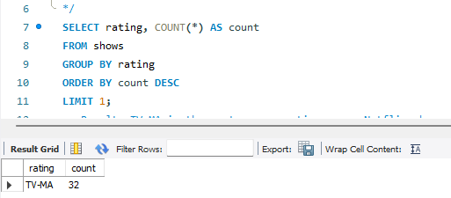

**Result:** TV-MA is the most common rating among Netflix shows.

**Cool Fact 2**: Average Release Year of Shows

SELECT AVG(release_year) AS avg_release_year

FROM shows;

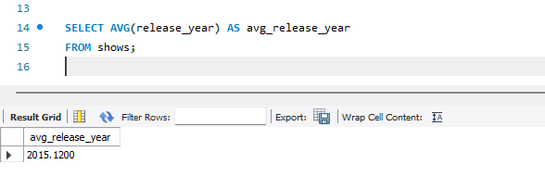

**Result:** The average release year of Netflix shows is around 2015, indicating a relatively recent content library.

* Use basic SQL queries like (COUNT, AVG, and SUM) to understand more about the data you have.

-- using count function to return the number all items from the dataset with (*)

SELECT count(*) FROM shows;

-- result: 100

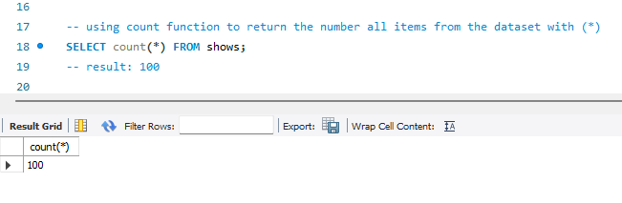

-- using sum() function to check for distinct value from data set

SELECT SUM(duration) FROM shows;

-- Result: 5646

-- meaning that there are  5646 minutes from the dataset. However some of the movies are in series such as season 1, season 2, 92 min, 120 min etc

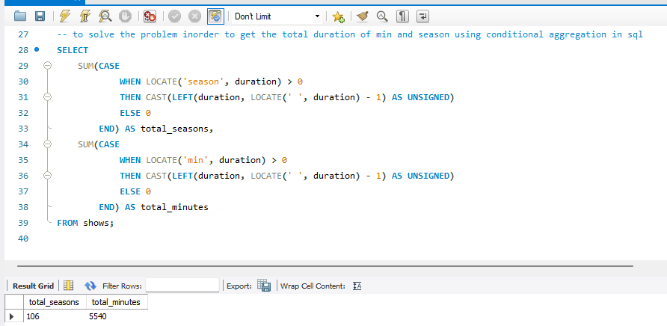

3. Ask Away (30 pts):

* Formulate 2 questions about the data (e.g.What are popular shows in different countries?).

3. Ask Away (30 pts):

**Question 1:** Which Country Produces the Most Netflix Content?

**Result:** The United States produces the most content on Netflix.

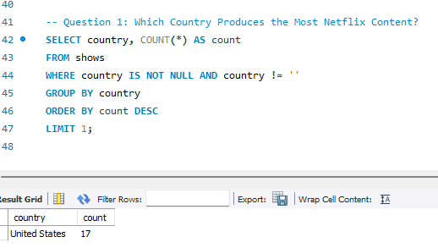

* Write basic SQL queries (WHERE, ORDER BY) to find answers.

 What are popular shows in different countries?

**Result:** the most popular countries appear based on the top 5 countries.

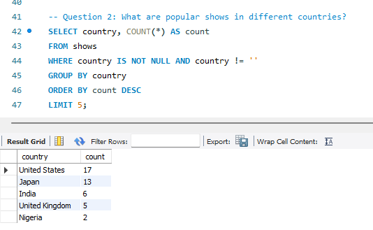

Question 2: What are the Top 5 Genres Listed on Netflix?

**Answer:** The top 5 genres listed on Netflix are:

1. Action & Adventure, Anime Features, International Movies
2. Children & Family Movies
3. Kid’s TV
4. Reality TV
5. Children & Family Movies, Comedies

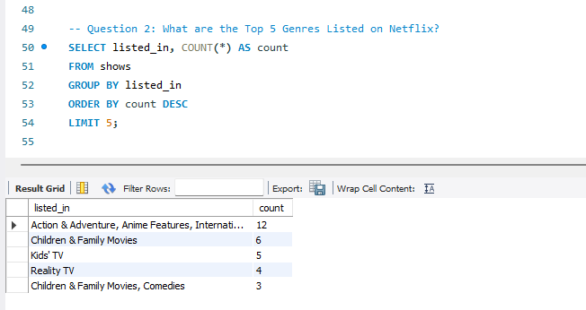

* Share what you learned from the answers.
* Learning:

**Country Production:** The dominance of the United States in content production for Netflix highlights the platform's American origin and major influence.

**Genre Popularity:** The diversity of genres indicates Netflix's strategy to cater to a wide range of audience preferences, ensuring there's something for everyone. The prominence of genres like International Movies suggests Netflix's global reach and content acquisition strategy.

4. Showtime! (20 pts):

* Use a tool (like Microsoft Excel charts) to create 3 charts showing your findings.
* Choose charts that clarify your discoveries using (bar charts, pie charts etc.).

5. Presentation Pitch Deck (20 pts):

* Prepare a short pitch deck presentation to showcase your work:
* Introduce the dataset and your goals.
* Briefly explain the import process and the interesting thing you found.
* Share the 2 cool facts you discovered.
* Discuss your questions, SQL queries, and what you learned.
* Present your charts and explain their meaning.
* Briefly summarize your project.

6.GitHub Repository:

* Create a public GitHub repository and upload the following:
* A document ( MS Word/ Textfile) containing all your SQL queries.

Google Form Submission: [In the provided Google Form](https://forms.gle/1vMi1oxq1sB8y2rz8), submit the link to your public GitHub repository and pitch deck.

Deliverables:

* Your SQL queries.
* A presentation pitch deck.

Grading:

* We'll look for clarity, effort, and interesting discoveries.
* Presentations will be evaluated on clarity and visual impact.

Bonus Points:

* Be creative! Think of different questions to ask about the data.
* Make your presentation engaging and easy to understand.